U1

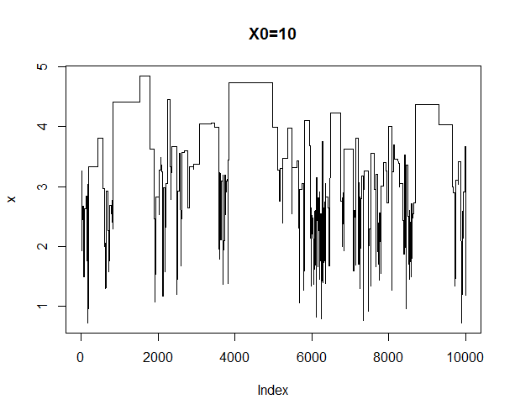

With lognormal proposal, the chain does not seem to converge, the mixing is very bad.

For high starting points, chain does not move.

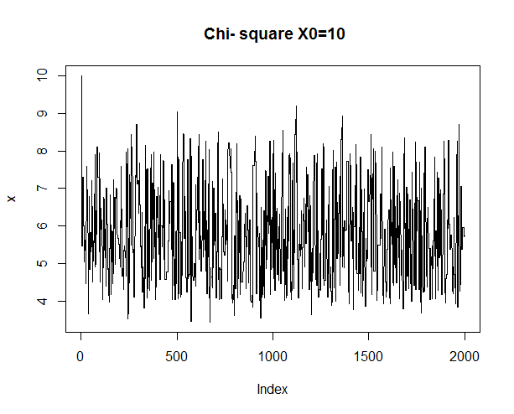

For chi-square mixing well, seems to converge.

> gelman.diag(f)

Potential scale reduction factors:

Point est. Upper C.I.

[1,] 1 1

Convergence is very good

Integral can be estimated as

> print(mean(x[1000:10000]))

[1] 5.929087

The distribution presented is gamma(6,1). Expected value is 6.

U2

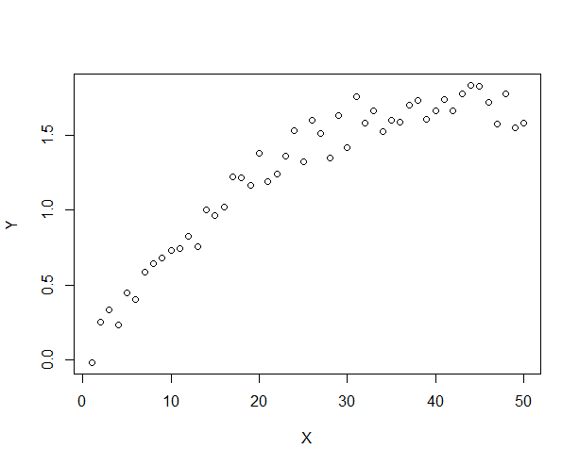

Kernel smoother or splines are OK



Now compute marginal pdfs:



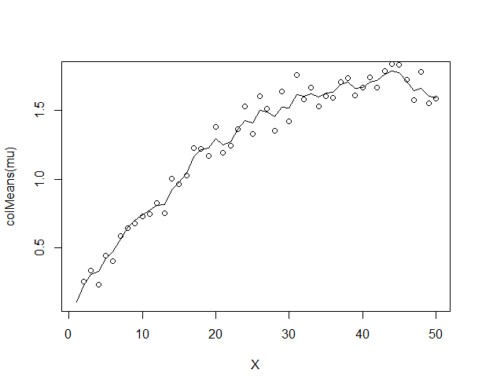

Noise seems to be removed, underlying dependence is catched

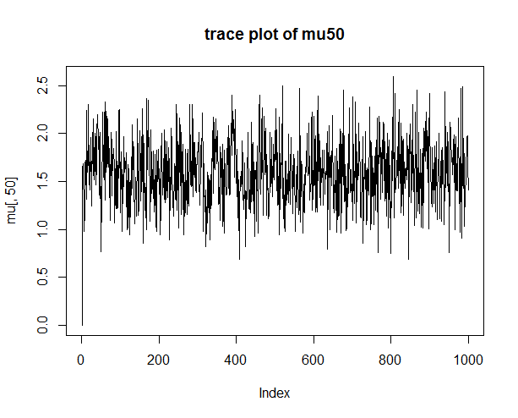

The burn-in period is very small, chains seems to be convergent